****Please do not change formatting or fonts—copy and paste as-is. Be sure to use the proper logo for your department****

Sample for The Children Guild Alliance:

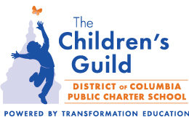
First Last, credentials
Title
The Children's Guild DC Public Charter School
2146 24th Place NE
Washington, DC 20018
c: xxx.xxx.xxxx
www.tcgdc.org

(**Please note the phone format is dots between sets of numbers. Add landline and/or fax as necessary. If you have a Guild issued cell phone, it must be listed**)

